WHO’S WHO GmbH
D-82205 Gilching Germany
Tel.: (+49-8105) 3906 53
Fax: (+49-8105) 3906 59
E-Mail: info@who.de
Internet: http://www.who.de
Trade Register Munich
HRB 195469
Managing Director:
Dr. Wolfgang Knödel
VAT-ID. DE 280534940
WHO'S WHO - PO-Box 1121 – D- 82205 Gilching Germany
WHO’S WHO
United European Business Editors Group

Order Form Database

To Editor@who.de

Or Fax 0049-8105-390659

❑ Yes, send us “Our companies business Contacts”
Database www. who-database.com ” (free unlimited access and multiuser search
for 1 Year (actual 20000 Top companies and biographies of their managers
in Europe for the special price of 450,- €. (+ VAT in Germany)
(find samples in www.who.de)
Please send invoice and password to
Name: Company
Direct Tel. Line: E-Mail……………………………..
Date…………………………………Signature

❑ Our department in charge will examine your additional offer for the premium
extention of our international Corporate Communication. Please call:
Mr./Mrs. ..................................Department ............................Tel.:...................
Thank you for your order
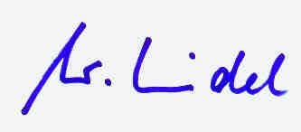
Dr. Wolfgang Knödel
-Chief Editor WHO’S WHO Europe-

